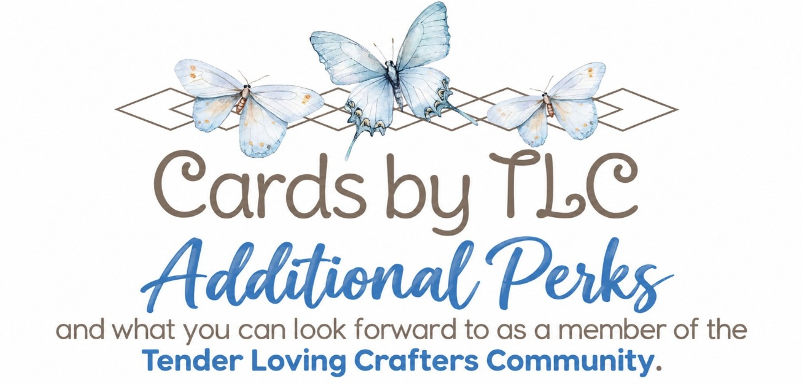
DISCOUNTS AND COMMISSIONS
- Enjoy your INSTANT 15% income/savings on all your purchases
- Extra income. You will earn extra income based on your sales and recruiting. How much is completely up to you. You just might want to buy something extra for yourself, or help with an extra bill, or just pay for your crafting hobby.
TENDER LOVING STAMPERS COMMUNITY
- Enjoy EXCLUSIVE PRIZE PATROLS, Challenges, tips and Techniques on our Private Facebook Group
- Exclusive Deals on Monthly Card Classes
- Weekly Facebook Lives, with Stampin’ Up! and Team Updates
ADDITIONAL TRAINING AND RESOURCES
- Stampin’ Up! Demonstrator Training site with videos, forms and ideas.
- EXCLUSIVE Stampin’ Up! Demonstrator Facebook Group where you see thousands of crafting inspiration and tips.
ADDITIONAL EXCITING PERKS
- See each Catalog before customers.
- Receive FREE catalogs from Stampin’ Up! several times per year
- Attend fun Stampin’ Up! Events throughout the year
- Sneak Peak and Early purchase opportunities before customers.
- Flexibility and Tax Benefits of enjoying your own business.
- Flexibility at any level you wish of running your own business- classes, stamping with friends, craft fairs, sell your finished projects, or just simply enjoy the discount.

